**CSE-4128**

Image Processing and Computer Vision Laboratory

Lab Report on Assignment-01

Topic: Convolution

|  |  |
| --- | --- |
| Roll | 1907005 |
| Name | Eleus Ahammad |
| Section | B |
| Group | B1 |
| 4th year | 1st semester |
| Date | 28.02.2024 |

**Introduction:**

This assignment explores the application of image convolution using the following kernels: Gaussian, Mean, Laplacian, and Laplacian of Gaussian (LoG) and Sobel. Every kernel also performs some arithmetic operation on image pixels to produce new images that are manipulated and enhanced. The task is designed to show the changes to the original picture in terms of sharpness, smoothness, and edge detection brought on by these kernels.

**Methodology:**

To achieve the assignment objectives, the following detailed steps were undertaken:

**1. Kernel Generation Functions:**

* Implemented separate functions to generate various types of kernels, including Gaussian, Mean, Laplacian, and Laplacian of Gaussian (LoG) filters.
* The Gaussian kernel generation function utilizes provided standard deviations along both x and y axes to create a Gaussian distribution.
* The Mean kernel function constructs a simple averaging filter to smooth images.
* The Laplacian kernel function is designed specifically for edge detection, highlighting abrupt intensity changes in images.
* The Laplacian of Gaussian (LoG) kernel combines the characteristics of both Laplacian and Gaussian filters, enabling edge detection with noise reduction.
* The Sobel filter detects edges by computing gradient magnitudes of image intensity at each pixel. Separate functions were implemented for horizontal and vertical edge detection, enhancing capabilities along different orientations. Resultant images offer insights into edge distribution and enable comparative analysis across different filtering techniques.

**2. Image Convolution:**

* Implemented the convolution operation to apply the generated kernels to input images effectively.
* The convolution process involves sliding the kernel over the image and computing the dot product between the kernel and the overlapped image region.
* This operation facilitates the modification of image attributes based on the characteristics of the applied kernel.

**3. Image Filtering:**

* Developed functions to apply convolution operations to input images using different types of kernels.
* Implemented separate functions to handle grayscale, RGB, and HSV images, ensuring compatibility across various image formats.
* By applying convolution with different kernels, images undergo filtering processes that enhance specific features or characteristics, such as smoothing, edge detection, or noise reduction.

**4. User Interaction:**

Implemented user prompts to facilitate interaction and customization of the convolution process.

* Users can select the type of kernel and specify its parameters, such as sigma values for Gaussian and LoG filters, size for Mean and Laplacian filters, and center coordinates for customizing kernel behavior.
* Provided options for different kernel types, including Gaussian, Mean, Laplacian, and Laplacian of Gaussian, sobel filters, allowing users to explore various filtering techniques.

**5. Result Visualization:**

* Utilized the OpenCV library to display the results of the convolution and filtering operations.
* Images were visualized to showcase the original input, convolved images, and differences between convolved RGB and HSV images.
* Normalization techniques were applied to ensure proper visualization of pixel intensities, enhancing the interpretability of the results.
* By following these detailed steps, the assignment successfully explores the effects of convolution kernels on input images, providing valuable insights into image processing techniques and their applications in various domains.

**Results and Discussion:**

The assignment yielded the following outcomes:

* The Gaussian filter effectively smooths the image while preserving important features.

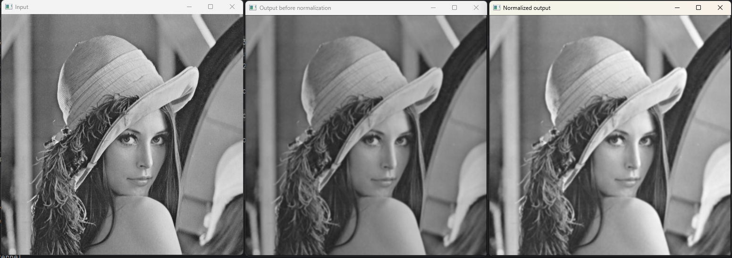

**Fig-1: Convolved output using Gaussian Filter**

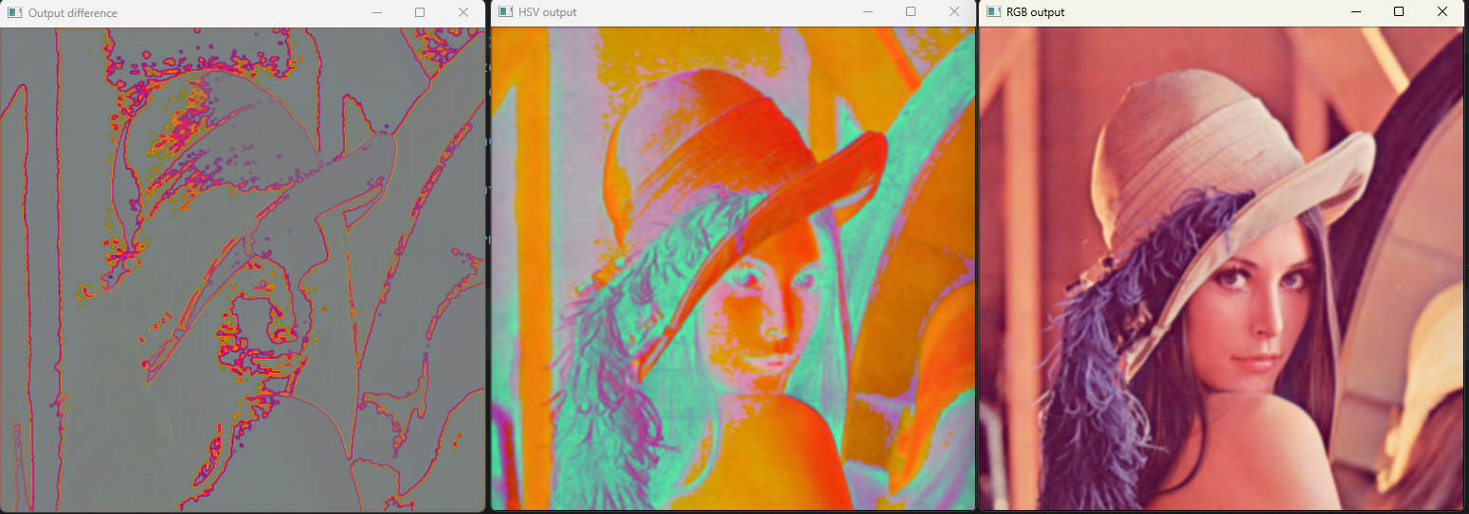

**Fig-2: Convolved in RGB and HSV mode and resultant difference**

* The Mean filter provides a basic smoothing effect but may blur edges and details.

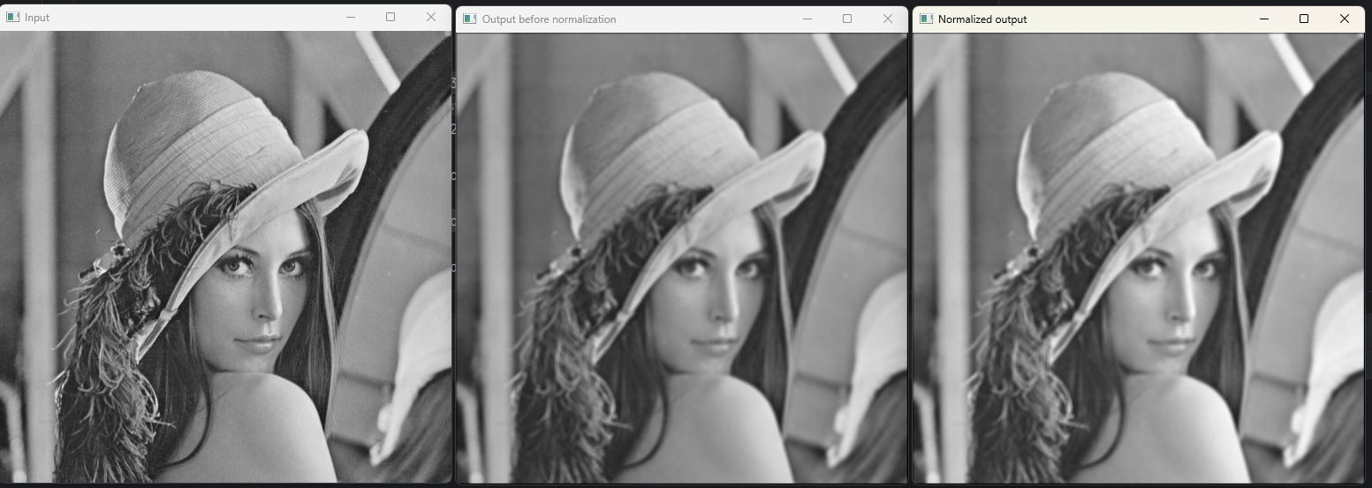

**Fig-3: Convolved output using Mean Filter**

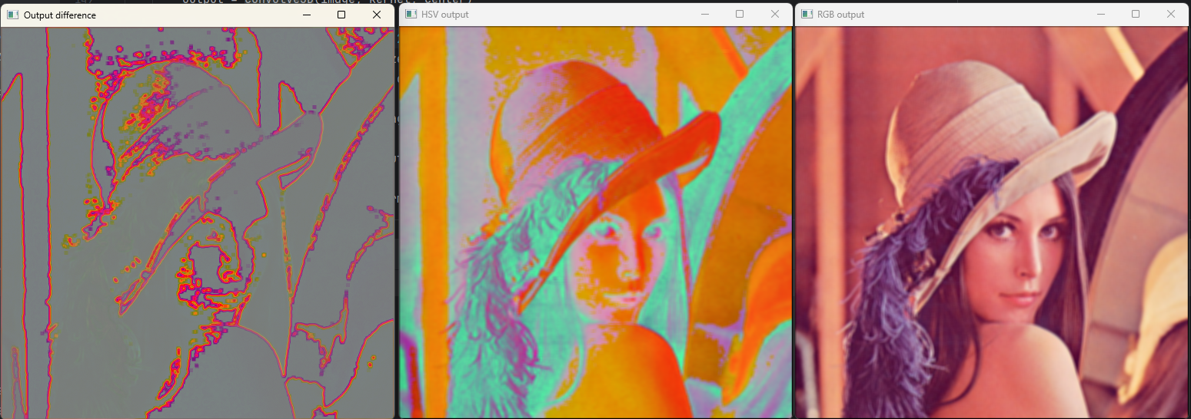

**Fig-4: Convolved in RGB and HSV mode and resultant difference**

* The Laplacian filter enhances edges and highlights abrupt intensity changes.

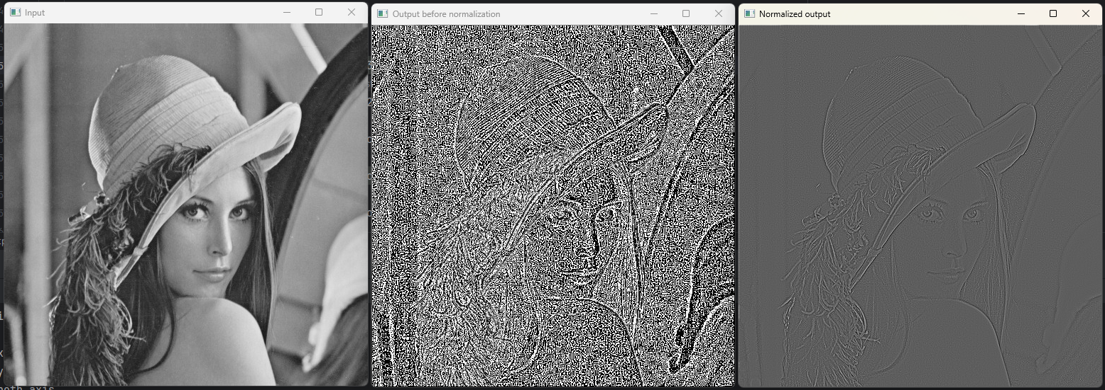

**Fig-5: Convolved output using Laplacian Filter**

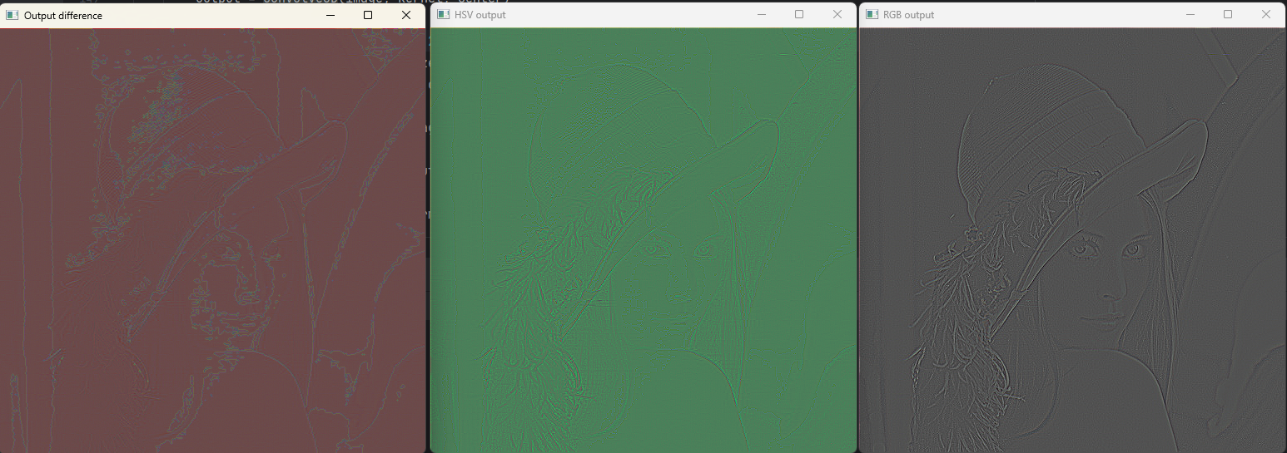

**Fig-6: Convolved in RGB and HSV mode and resultant difference**

* The Laplacian of Gaussian filter combines noise reduction with edge detection, providing robust results.

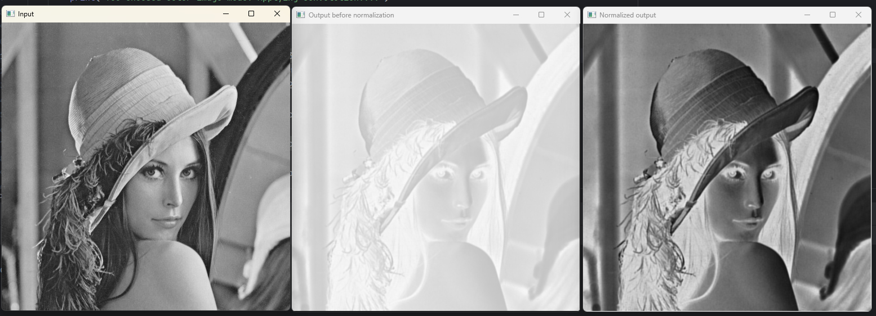

**Fig-7: Convolved output using LoG Filter**

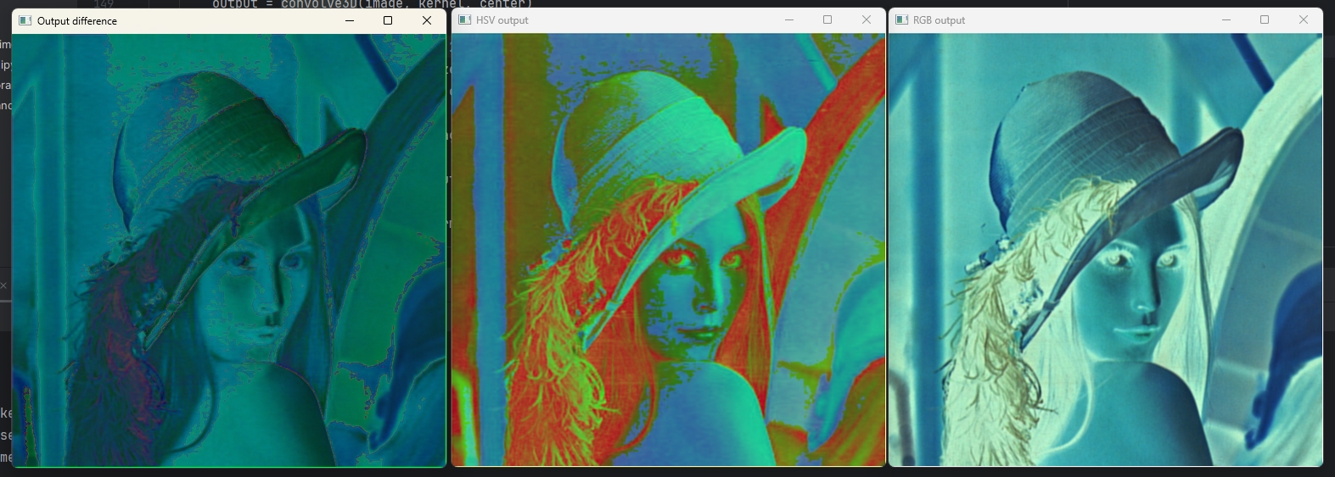

**Fig-8: Convolved in RGB and HSV mode and resultant difference**

* The Sobel filter efficiently enhances edge detection by computing gradients along both horizontal and vertical orientations, providing comprehensive edge information for detailed image analysis.

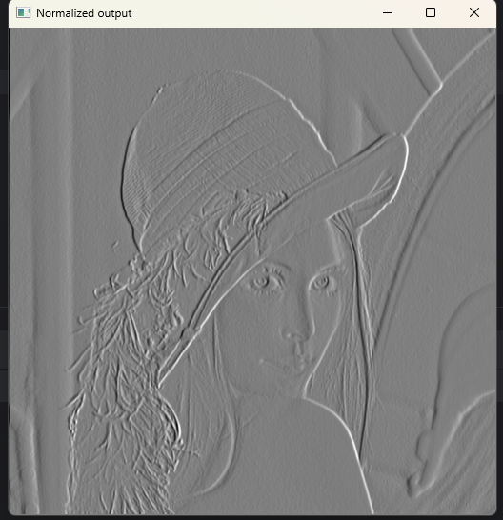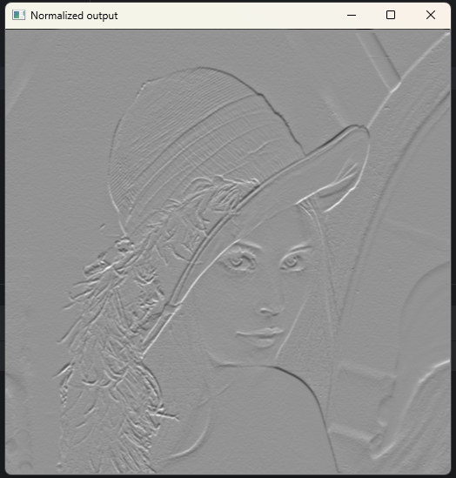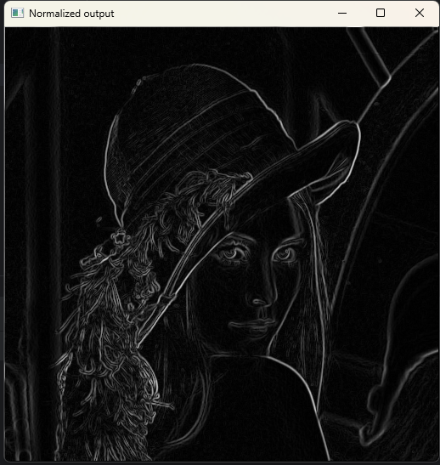

**Fig-9: Convoluted outputs using Sobel filter both horizontally and vertically**

**Conclusion:**

Through this assignment, we explored various image filtering techniques using convolution operations and observed their effects on different types of images. The implementation of convolution and filtering operations provides essential tools for image enhancement, feature extraction, and edge detection in computer vision and image processing applications. Further experimentation and optimization can lead to more advanced filtering algorithms tailored to specific image processing tasks.